**covering letter**



Respected sir,

I Preetimoy Patra, very much interested to make good career with your esteemed organization, I wish to submit my resume for your kind consideration. I believe that I meet your requirements and will be able to prove my abilities if given a chance and be a valuable member of a team. I am looking forward to discuss regarding the employment opportunity at your earliest convenience

Sir, I would be very grateful if you pay heed to my request and inform me of the possible recruitments and vacancies in the company that meet my requirements and please kindly inform me on this number and E-mail

With humble regards,

Preetimoy Patra

Mobile no- 91-9090342525

Mail:- preetimoypatra2@gmail.com

**Accomplished Professional with Experience in Marketing**

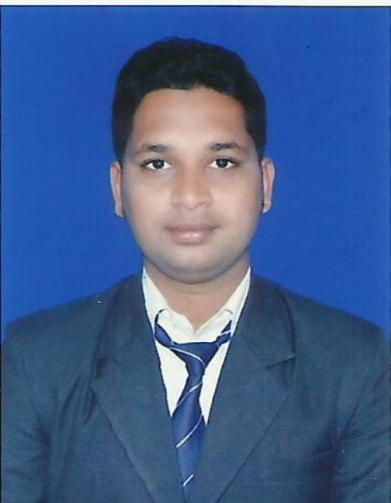

**PREETIMOY PATRA**

**Address:**

QR. No-B/212, Sector-4,

P.O. Rourkela-4,

P.S – Sector-3,

Dist. – Sundargarh,

Odisha – 769002.

**Contact No:** +91-9090342525;

**Email:preetimoypatra2@gmail.com**



**ASPIRING MARKETING PROFESSIONAL**

Seeking a challenging and rewarding opportunity in the industry which is inline with my academic background and which effectively utilizes myanalytical and technicalskills.



**SUMMARY OF SKILLS**

* Dedicated, hardworking and result oriented with a strong will to excel, capable of taking responsibilities independently.
* Self motivated, goal-oriented with a high degree of flexibility, creativity, resourcefulness, commitment & optimism, determined to carve a successful and satisfying career in the industry.
* Conceptually strong with an innovative and analytical & systematic approach to the work with an eye for detail. Enriched with the ability to learn new concepts & technology within a short span of time.
* An effective team player with exceptional planning & execution skills coupled with Interpersonal & Communication skills along with clarity of fundamentals with perseverance to succeed & zeal to achieve.



**professional experience:-**

**CURRENTLY WORKING AT :**

**Company Name:** ZENITH STEELS

**Department:** Marketing Executive

**Profile:**

* Meeting team of Technical Officers, Corporate Clients, Project Management Consultants and delivering business presentations to them on company profile, on technical details associated with products & services.
* Overall activity starting from specifying company’s product in BOQ, providing tender estimates & budgetary offers, order negotiation& completion of task to close the order.
* Enrolling new clients & avenues.
* Generating new project database and enquiries.
* Maintaining relationship with existing clients to generate repeat orders.
* Co-ordinating with purchase department, stores and project department for smooth execution of task.
* Team planning & deployment based on assignment.
* Brand promotion
* Handling dealer network
* Monitoring timely deliver to customer
* Co-ordinate effectively with dealers and distributors implement policies and operating procedures to ensure operational effectiveness of business

**Date of Joining:** 26th October, 2015 - Till date.

**Address:** Bhubaneswar, Odisha.



**ACADEMIC CREDENTIALS**

1. MBA (Marketing,HR) from Rourkela Institute of Management Studies, Rourkelain 2015.
2. BBA under Sambalpur Universityin 2010.
3. Completed 12th from (CHSE)in 2007.
4. Completed 10th from (BSE)in 2004.
5. P.G.D.C.A at See-Net, Rourkela.
6. HCL Certified Engineer (HCE) from HCL

.

**­­­­­­­­**



**INTERNSHIP PROJECT**

ORGANISATION: ROURKELA STEEL PLANT (RSP).Rourkela

AREA: HUMAN RESOURSE

PROJECT TITLE**:** Industrial Relation of RSP



**TECHNICAL SKILLS**

* MS Windows 98, 2000, XP.
* Ms – Office 2003,Excel
* Accounting Software - **Tally 9.0**
* Hardware in C-net Rourkela



**EXTRA CURRICULAR ACTIVITIES**



* Program coordinator in INTERNATIONAL CONFERENCE 2013.
* Program Volunteer in Marketing Mela 2013 & 2015.
* Winner of BASKETBALL and CRICKET TOURNAMENT in college athletic meet
* I got certificate Akhila bharatiya Sanskrit, gyan

**PERSONAL INFORMATION**

**Date of Birth: 16**th May, 1989.

**Father’s Name:** Mr. Akshaya Kumar Patra.

**Hobbies:** Listening to music, playing cricket, net surfing.

**Languages Known:** English, Hindi, and Odia.

**References:** Available on request

***The information furnished above is true and correct according to the best of my knowledge and belief.***

**Date:**

**Place: PREETIMOY PATRA**